
Dashboard Design

Date | 27 October 2026
Team ID | Individual
Project Name | Global Olympic Sports Performance Analysis
Maximum Marks | 5 Marks

Activity 1: Interactive and visually appealing dashboards
Creating an effective Streamlit dashboard involves presenting business data stored in Snowflake through clear, interactive, and easy-to-understand visualizations. Students should design the dashboard so that users can quickly understand important KPIs, trends, comparisons, and business insights.
- Clear and Intuitive Layout
- Use Appropriate Visualizations
- Colour and Theming
- Interactive Filters and Slicers
- Drill-Down Capabilities
- Responsive Design
- Custom Visuals and Icons
- Use of Infographics

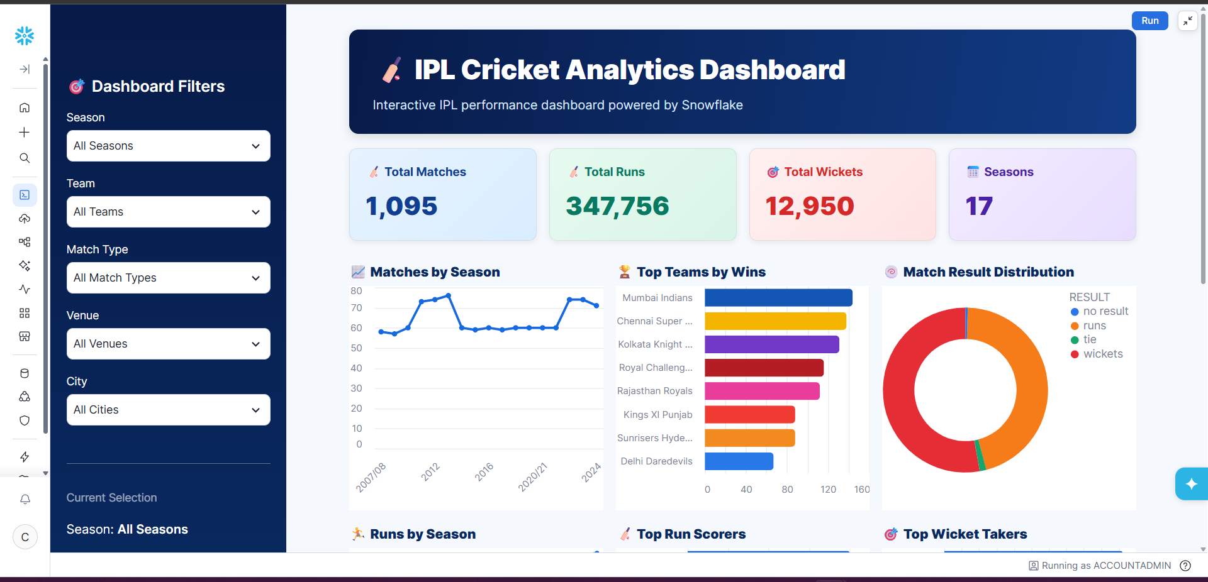
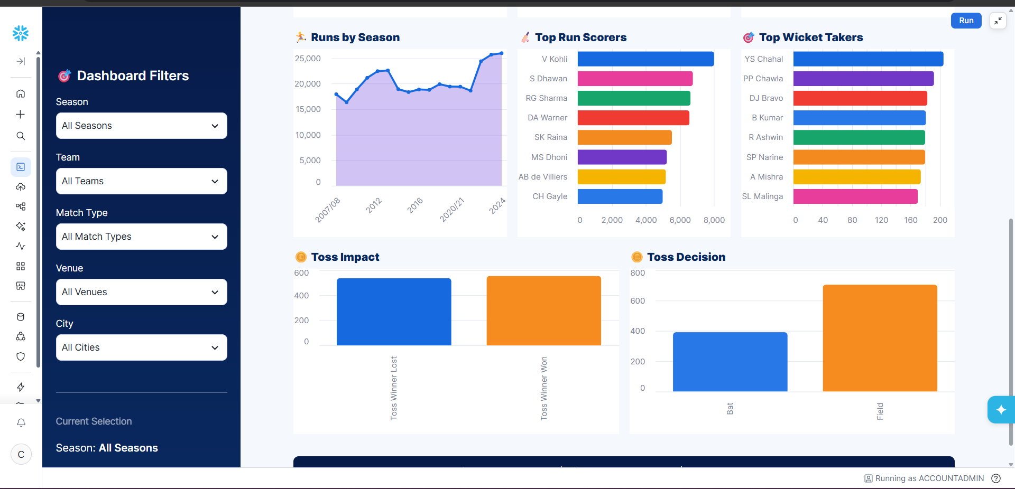
Note: Highlight the major outcomes in form of bullet points
Sample:
Here are five potential outcomes from the dashboard image provided:
- Mumbai Indians emerge as the strongest team by wins
Mumbai Indians are shown at the top of the Top Teams by Wins chart, indicating consistently strong performance across IPL seasons.
- Batting performance is dominated by a few key players
V. Kohli leads the Top Run Scorers chart, followed by players such as S. Dhawan, RG Sharma, and DA Warner. This highlights the importance of high-performing batsmen.
- Wicket-taking performance is concentrated among leading bowlers
YS Chahal ranks highest in the Top Wicket Takers chart, followed by PP Chawla and DJ Bravo, indicating that a relatively small group of bowlers has contributed significantly to wicket-taking.
- Fielding/toss decisions appear to have an impact on match outcomes
The Toss Impact and Toss Decision charts show differences between winning after winning the toss and choosing to bat vs. field. This can be used to investigate whether the toss provides a meaningful advantage.
- IPL match activity and scoring have grown over the seasons
The Matches by Season and Runs by Season charts show variation and an overall increase in IPL activity and run production across seasons, with particularly high run totals in later seasons.
Olympic medal rankings, medal-type comparisons, Summer/Winter performance, sport-category averages, regional efficiency, investment-tier comparisons, historical trends, athlete participation, and host-nation performance.

Project Context
Global Olympic Sports Performance Analysis. Team ID: Individual. Documentation date: 27 October 2026.
Implementation Status
The nine-sheet, three-dashboard structure is the agreed project plan. Actual performance measurements, screenshots, final observations, and public links should be added only after the Tableau workbook is completed and tested.

